Promoted for and on behalf of Cycling Time Trials under its Rules and Regulations

GARY DIGHTON MEMORIAL 10 MILE TIME TRIAL
SUNDAY 26th June 2022 Results
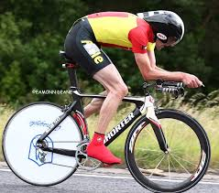

Organiser: Mark Valentine, 16 Cowper Road, Moordown, Bournemouth BH9 2UJ.
078133 21314 sirmarkavalentine@hotmail.com
Timekeepers:
Bev Wadsley Poole Wheelers
Ros Spencer Poole Wheelers
Tom Kelley, Poole Wheelers
Thank you to all the marshals and the support team for help in running the event

PRIZE LIST

TT
First man Samuel Wadsley P-TJ £30
Second man Alastair Luxford Full Gas £20
Third man Paul Jones P-TJ £15
Fourth man Tom Clements Wessex £10

First lady Kirsty McSeveney a3crg £30
Second lady Rebecca Pearce Ridgeway £20

First vet on Std David Butt Weymouth £25
Second vet on Std Pete Wilson Bmth Arrows £15
First Vet on Time Steven Pink PWCC £25
Second vet on Time Andrew Rivett VC St Raphael £15

First Junior/Juvenile £15
George Terry PWCC

Fastest team £15 each
Samuel Wadsley P-TJ
Paul Jones P-TJ
Julian Lockwood P-TJ

Road
First Man Dave Dent GS Stella £20
First Lady Louisa Cooper BJW £20

Please make contact if you have won a prize and didn’t receive it

Thank you
Mark Valentine

